**ARTIFICIAL INTELLIGENCE PROJECT**

**Customer services CHATBOT**



**SUBMITTED BY:**

ABDUL MOIZ (01-134201-004)

MUHAMMAD SAMAD (01-134201-062)

HAMZA AFTAB ABBASI (01-134201-027)

**SUBMITTED TO:**

MA’AM FAIMA ABBASI

Contents

PROJECT ABSTRACT: 2

INTRODUCTION: 2

OVERVIEW: 2

OBJECTIVES: 3

PROJECT SCOPE AND LIMITATIONS: 3

SCOPE: 3

LIMITATIONS: 3

• The Chabot which we designed don’t understand human context. 3

• The Chabot which we designed do customer retention. 3

• The Chabot which we designed can’t make decisions. 3

• Our Chat bot will have the same answer for a query. 3

APPLICATION AREAS: 3

METHODOLOGY: 4

FLOW DIAGRAM: 4

TYPE OF CHATBOT: 4

THE ALGORITHM WE CHOOSED: 5

HOW THE ALGORITHM PROCESSES? 5

STEPS FOR CREATING OUR CHATBOT TO FINAL OUTPUT: 5

LANGUAGE ON WHICH CHATBOT IS DEVELOPED: 5

CONCLUSION 5

CODE OF PROJECT: 6

CODE: 6

GUI OF DESIGNED CHATBOT: 10

# PROJECT ABSTRACT:

Instead of offering direct contact with a live human agent, a chat-bot is a software application that is used to conduct an online chat conversation using text or text-to-speech, designed to accurately mimic how a genuine conversation partner would conduct them. We included a Chabot that creates a dynamic response to online clients' questions in the suggested system. The proposed system is based on a Chabot that uses artificial intelligence. The web-based platform offers a sizable cognitive base that can aid in simulating human problem-solving. This hypothetical Chabot recognizes the user context that prompts a specific purpose for a response. The user will receive the desired response because it is a dynamic response. By observing different user answers and requests, the suggested system used machine learning methods to learn the Chat bot. These days, Chabot’s are starting to be quite capable since artificial intelligence helps the human touch in every discussion, enables Chabot’s to understand users' questions, and enables them to deliver accurate responses. The goal of this project is to demonstrate how chat bots can lessen an organization's reliance on humans and the demand for various systems for various operations.

# INTRODUCTION:

## OVERVIEW:

The big issue that is faced by companies in today’s era is the customer questions, requests, transactions like customers asks/questions for different products and services and want feedback on the product and services they want and which wastes a lot of the time of companies and sometimes even the companies are not able to answer every customer’s query because companies employees are not available 24/7. So companies are challenged to find a way to introduce a solution to this issue. In our project, we will create a chat bot to tackle this issue of companies.

Our chat bot will interact with different customers and answer their questions/queries more quickly and comprehensively. Moreover, our chat bot will interact with different customers those who want their queries to be answered quickly; in a timely manner, as time waste is a big issue that the companies faced and our chat bot will solved that.

## OBJECTIVES:

* Our chat bot will
* Give people an automated way to communicate with your company
* Provides 24/7 customer support.
* Listen to customer’s queries.
* Reply to customer’s queries.
* Advice the customers.
* Respond to customer’s queries more quickly.

## PROJECT SCOPE AND LIMITATIONS:

### SCOPE:

The scope of our chat bot is that it will be available to customers 24/7 and will answer queries of customers at every time and will reply to them more quickly and reliably without taking any help from humans.

### LIMITATIONS:

### The Chabot which we designed don’t understand human context.

### The Chabot which we designed do customer retention.

### The Chabot which we designed can’t make decisions.

### Our Chat bot will have the same answer for a query.

## APPLICATION AREAS:

* Our designed Chabot will be useful for different industries which are listed below:
* E-commerce Industry
* Medicine Industry
* Travel Industry
* Real Estate
* Banking Industry
* Hospitality
* Hotel Industry
* Food tech Industries

# METHODOLOGY:

## FLOW DIAGRAM:

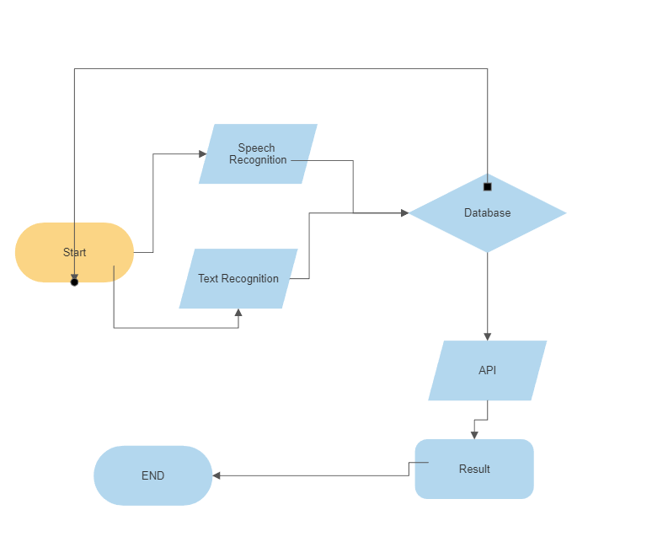

## TYPE OF CHATBOT:

We are creating a voice-based and keyword-recognition-based Chabot. These Chabot’s decide how to respond to the user by using programmable keywords and an AI tool called Natural Language Processing (NLP). Businesses are already starting to deploy voice-based chat bots or voice bots to make conversational interfaces even more casual. Voice bots have become increasingly popular over the past few years, with virtual assistants like Apple's Siri and Amazon's Alexa leading the way. But why? owing to the convenience they offer. For a consumer, speaking is far simpler than typing. A voice-activated Chabot provides the customer with frictionless interactions.

## THE ALGORITHM WE CHOOSED:

The ability of computer software to comprehend spoken and written natural language is known as natural language processing (NLP). A part of artificial intelligence, it is.

### HOW THE ALGORITHM PROCESSES?

Computers can now comprehend natural language just like people do thanks to NLP. Natural language processing use artificial intelligence to take real-world input, process it, and make sense of it in a way that a computer can comprehend, regardless of whether the language is spoken or written. Computers have reading programs and microphones to collect audio, much as people have various sensors like ears to hear and eyes to see. Computers have a program to process their various inputs, just as humans have a brain to do so. The input is eventually translated into computer-readable code during processing.

### STEPS FOR CREATING OUR CHATBOT TO FINAL OUTPUT:

* [Decide your chat bot’s purpose](https://www.userlike.com/en/#purpose)
* [Give your chat bot a persona](https://www.userlike.com/en/#persona)
* [Create a conversation diagram](https://www.userlike.com/en/#diagram)
* [Write conversation scenarios](https://www.userlike.com/en/#scenarios)
* [Test your conversation flow](https://www.userlike.com/en/#flow)
* [Wrap up the conversation](https://www.userlike.com/en/#ending)

## LANGUAGE ON WHICH CHATBOT IS DEVELOPED:

* HTML
* JAVA SCRIPT

## CONCLUSION

 A chat bot is one of the simple ways to transport data from a computer without having to think for proper keywords to look up in a search or browse several web pages to collect information; users can easily type their query in natural language and retrieve information.

## CODE OF PROJECT:

### CODE:

<!DOCTYPE html>

<html>

<head>

<title>Chatbot</title>

<style>

body {

color: #6D0D0C;

font-weight: bold;

font-size: 18px;

}

span {

color: #711;

}

::-webkit-input-placeholder {

color: #713

}

#main {

position: fixed;

top: 40%;

right: 60px;

width: 350px;

border: 2px solid #CD5C5C;

padding: 40px;

background-color: white;

}

#main div {

margin: 1px;

}

#input {

border: 0;

padding: 5px;

border: 1px solid #421;

}

</style>

</head>

<body>

<center><p1> Welcome To my Chatbot</p1></center>

<hr>

<hr>

<!-- <p2 style="color: darkgreen;"> Welcome to the chat bot </p2> -->

<div id="main">

<div>user: <span id="user"></span></div>

<div>chatbot: <span id="chatbot"></span></div>

<div><input id="input" type="text" placeholder="Enter Your Query" autocomplete="off" /></div>

</div>

<script type="text/javascript">

var trigger = [

["hi", "hey", "hello"],

["how are you", "how is life", "how are things"],

["what are you doing", "what is going on"],

["how old are you"],

["who are you", "are you human", "are you bot", "are you human or bot"],

["who created you", "who made you"],

["your name please", "your name", "may i know your name", "what is your name"],

["i love you"],

["happy", "good"],

["bad", "bored", "tired"],

["help me", "tell me story", "tell me joke"],

["ah", "yes", "ok", "okay", "nice", "thanks", "thank you"],

["bye", "good bye", "goodbye", "see you later"],

["one way flight prices to Athens", "one-way flight to Santa Clara",

"How much is a one-way ticket from Montreal to Tokyo if I leave on March 5 and return on March 10?",

"looking for one way ticket to taipei", "how much is one way flight to Seoul?",

"what is the price of one way flight to taipei?", "what is the price of a direct one-way flight to Detroit?",

"need one way flight to Paris", "looking for direct one-way flight to london",

"What is the price of a one-way ticket from Dubai to Paris if I leave on May 24?",

"Tell me about one way flights from Frankfurt to London?", "One way from London to Toronto?",

"One way from Dubai to London", "One way trip from Frankfurt to Paris?", "Going to Shanghai",

"Want to go to Seoul", "One way to Jakarta", "One way to Hanoi from Hong Kong", "One-way flight to Dubai",

"Is there a one way trip to Bordeaux?", "Can I info for one-way trip from Dublin to Porto?",

"Want to go to Madrid", "From Madrid to Vienna, one-way flight", "Find me the price for one way trip from Hanover to Basel",

"Searching for one-way from Hanover to Toronto", "Give me the price for a trip from Hanover to Basel",

"Are there flights from London to Madrid?", "Looking for one-way flight from London to Hong Kong", "One-way flight to Edinburgh",

"Looking for one way flights between Toronto and London", "Help search one way flight from London to Hong Kong",

"One way trip from Athens to Frankfurt.", "What is the price of a round trip from Toronto to New York City if I leave on Feb 2 and coming back on Feb 5?", "search for round trip to Hong Kong", "i will need a roundtrip flight to San Jose", "need a roundtrip ticket to Hawaii", "looking for round trip flight to London", "i need a roundtrip info between vancouver and toronto", "Round trip from Montreal to Vancouver?", "Round-trip from Toronto to San Francisco", "Price for roundtrip from Toronto to New York City if I leave on Feb 2 and coming back on Feb 5?", "Round trip from Montreal to Vancouver?", "Price for trip from San Jose to New York City leaving on Feb 2 and returning on Feb 5?", "Flight from San Jose to New York City leaving on Feb 2 and returning on Feb 5?", "Roundtrip flight between San Jose and New York City leaving on Feb 2 and returning on Feb 5?", "Price for roundtrip flight going from Toronto to Hong Kong leaving on Feb 2 and returning on Feb 25?", "Round trip flight between Arizona and New Jersey leaving on May 6 and returning on May 10?", "Round-trip from Toronto to San Francisco", "Osaka to Toronto, leaving Dec 1 and returning on Jan 12", "Shanghai to Toronto round trip", "I want to know the roundtrip price between Turin and Moscow", "What is the price for roundtrip going from Toronto to Shanghai?", "roundtrip from San Francisco to Toronto, leaving Oct 24 returning on Nov 30", "looking for round-trip info for Baltimore and San Francisco", "I am looking a roundtrip price for flights between Hong Kong and Seoul", "Find me roundtrip price between Toronto and Hong Kong between Jan 14 and Feb 28", "Roundtrip tickets from Toronto to Vancourver", "Looking for roundtrip from Ottawa to Detroit", "Help with look for round trip prices from Paris to London.", "Looking for roundtrip price from Paris to Monaco", "Help me look for round trip flight from Detroit to Las Vegas", "Want to know price of round trip from Ottawa to Calgary"]

];

var reply = [

["Hi", "Hey", "Hello"],

["Fine", "Pretty well", "Fantastic"],

["Nothing much", "About to go to sleep", "Can you guess?", "I don't know actually"],

["I am 1 day old"],

["I am just a bot", "I am a bot. What are you?"],

["Kani Veri", "My God"],

["I am nameless", "I don't have a name"],

["I love you too", "Me too"],

["Have you ever felt bad?", "Glad to hear it"],

["Why?", "Why? You shouldn't!", "Try watching TV"],

["I will", "What about?"],

["Tell me a story", "Tell me a joke", "Tell me about yourself", "You are welcome"],

["Bye", "Goodbye", "See you later"],

["The price is 150$"]

];

var alternative = ["Haha...", "Eh..."];

document.querySelector("#input").addEventListener("keypress", function (e) {

var key = e.which || e.keyCode;

if (key === 13) { //Enter button

var input = document.getElementById("input").value;

document.getElementById("user").innerHTML = input;

output(input);

}

});

function output(input) {

try {

var product = input + "=" + eval(input);

} catch (e) {

var text = (input.toLowerCase()).replace(/[^\w\s\d]/gi, ""); //remove all chars except words, space and

text = text.replace(/ a /g, " ").replace(/i feel /g, "").replace(/whats/g, "what is").replace(/please /g, "").replace(/ please/g, "");

if (compare(trigger, reply, text)) {

var product = compare(trigger, reply, text);

} else {

var product = alternative[Math.floor(Math.random() * alternative.length)];

}

}

document.getElementById("chatbot").innerHTML = product;

speak(product);

document.getElementById("input").value = ""; //clear input value

}

function compare(arr, array, string) {

var item;

for (var x = 0; x < arr.length; x++) {

for (var y = 0; y < array.length; y++) {

if (arr[x][y] == string) {

items = array[x];

item = items[Math.floor(Math.random() * items.length)];

}

}

}

return item;

}

function speak(string) {

var utterance = new SpeechSynthesisUtterance();

utterance.voice = speechSynthesis.getVoices().filter(function (voice) { return voice.name == "Agnes"; })[0];

utterance.text = string;

utterance.lang = "en-US";

utterance.volume = 1; //0-1 interval

utterance.rate = 1;

utterance.pitch = 2; //0-2 interval

speechSynthesis.speak(utterance);

}

</script>

</body>

</html>

## GUI OF DESIGNED CHATBOT:

